Photon PUN2 Enter Exit with Realistic Car Controller V3.5

# Importing Packages

First, download and import **Photon2**. Pass your AppID to Photon setup (expalined below), and then import “**RCC_PhotonNecessaryScripts**” in **Scripts/Photon** folder. Now you can test the Photon demo scene.

There should be a new scene named “**RCC City Enter Exit FPS (Photon PUN2)**” in **Demo Scenes** folder after importing the integration package. Same scene with regular Photon PUN2 city scene. Only difference is, this scene has “**BCG_PhotonManagerEnterExit**” instead of “**RCC_PhotonManager”** with script.

# Known Bug

There is an option named “**Enable Photon Enter Exit**” button in **Enter Exit Settings**. This button needs to be refreshed. Disable it and re-enable it. This process will add “**BCG_ENTEREXITPHOTON**” scripting symbol into your **Build Settings**. Disabling it again will remove this scripting symbol from your **Build Settings**.

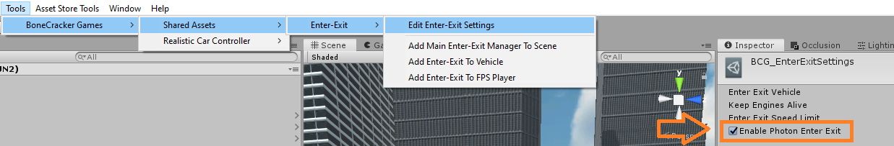

I would recommend you to read **Realistic Car Controller V3.4 Photon PUN2 Integration** documentation before reading this.

Once we connect to lobby with “**BCG_PhotonManagerEnterExit**”, automatic room join/create will be initiated. After creating / joining random room, “**Spawn Player**” button will be visible. This button is only visible when we are in active room. This button will instantiate **BCG_FPSPlayer** with “**PhotonView**” component attached to it.

Each vehicle on the scene has “**RCC_PhotonNetwork**”, “**BCG_PhotonNetwork**” scripts. When FPS Player enters the vehicle, “**BCG_PhotonManagerEnterExit**” will request ownership of the vehicle to the FPS Player. When FPS Player exits the vehicle, “**BCG_PhotonManagerEnterExit**” will transfer ownership to 0. That means, owner of the vehicle is null.